12/2/2021

ISLAMIC STUDIES

SEMESTER PROJECT (INDIVIDUAL)

SYED SHAH HUSSAIN BADSHAH

(FA21-BSE-083)

Current Social, Moral and Political Problems and Challenges of Muslims and their Solutions in the Light of Islamic Teachings:

**(Topic: Stereotypes About Islam : Myths and Facts)**

**Introduction:**

A stereotype is defined as any widely held public opinion about a particular social group or person. Stereotypes are often mistaken with prejudices, as they are built on fixed notions. Stereotypes about people of different cultures or races are common.

Stereotypes about Islam are the assumptions people have that Muslims are responsible for every bad or evil that happens.

Islamophobia is one of the reasons of these stereotypes. Islamophobia is the fear and hatred of Islam or preconception towards Islam or Muslims in general, especially when they are supposed as a geopolitical power or a source of terrorism throughout the world. People are afraid of getting aawareness about Islam. Due to lack of knowledge about Islam, people build these assumptions.

**Findings and Discussions:**

There are 1.6 billion Muslims in the world, making Islam is the second largest religion of world after Christianity. There's loads of idea and misinformation regarding Islam and Muslims in several countries. What is more, the increase of anti-Muslim inflation, additionally because the ruinous association of terrorist act with Muslims, as well as the catastrophic association of terrorism with Muslims, strengthens misconceptions and stereotypes. As a consequence, Islamophobia—fear, hatred, and bigotry against Muslims—has taken root in personal prejudices, education, politics, and other areas.

**Myths and Facts about Islam:**

* **Islam is a violent religion :**

Islam does not appreciates the assassination of innocents .Most Muslims deplore violence as much as any non-Muslim, and they hate being labelled violent based on a common faith or a specific group's magniloquence. "Does blasting of a building in Oklahoma City means that whole Christian society is terrorist?". When there are hundreds of battles and millions of people killed by Christian governments , why don't we have stereotypes against Christianity? I believe the question should be who executed this stereotype in terms of power relations to justify Iran as a nation.

Saying that religion is violent is a stereotypical, negative remark in my opinion, because every religion has teachings about how to solve problems peacefully. Many religions have teachings that justify the use collaboration, and persuasion in conflict resolution.

The Prophet (PBUH) said,

“The most hated person in the sight of Allah is the most quarrelsome person.” (Sahih Bukhari)

* **Importance of peace in Islam:**

In Quran Allah (SWT) mentioned that:

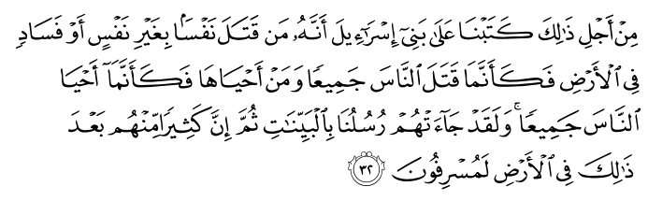

“ He who kills a soul unless it be (in legal punishment) for murder or for causing disorder or corruption on the earth will be as if he had killed all humankind and he who saves a life will be as if he had saved the lives of all humankind “(Verse 5:32)

* **Islam oppresses women:**

The head scarf is often used to illustrate inequality. Both men and women are instructed to dress modestly in the Quran, but how this is perceived and carried out differs greatly. Many people believe Muslim women are compelled to wear a veil, niqab. This is not the case everywhere. In reality, many women prefer to wear a hijab on their own for a number of reasons, including pride in being Muslim or to express a sense of selfcontrol in public.

Leadership is another indicator of women's position in Muslim culture. Turkey, Indonesia, Senegal, Kosovo, Kyrgyzstan,Bangladesh, Pakistan, and Mauritius have all had Muslim women as their heads of state since 1988

Islam was a significant change for women, giving them new rights such as the right to choose their spouse, education, and sharein family inheritance. Men and women are treated equally by Allah (SWT) according to the Quran.

Islam has raised the status of women from earth to so high that paradise lies below the feet of a mother .

It's also important to recognise that, as with other religions, people in positions of authority will occasionally use faith as an excuse to justify women's oppression.

* **Muslims are barbaric people:**

The simplicity of Islam's principle—Islam requires confidence in mere one God deserve worship—is one of the explanations for its speedy and peaceful unfolding. It additionally tells man to use his intellect and empirical skills.

Great civilizations and universities arose in a matter of years, because according to the Prophet (PBUH),

“Finding knowledge is an obligation for every person."

Important advances were made in, physics ,medicine, mathematics, astronomy, literature ,geography and history as a result of the convergence of Western and Eastern designs, as well as updated thinking .Many vital systems were transmitted to feudal Europe from Islam.

Many say that Muslims are wedged in the Middle Ages, incapable to familiarize with the modern world. No, they are not. Muslims are a locality of the fashionable world. Even the foremost hard-line Islamists try to work out a way to live as successful Muslims within the present, instead of seeking to travel back in time .

* **Islam, a sword-based religion:**

Social studies textbook depict an Arab horseman with a sword in one hand and the Quran in the other. This, however, is not an true portrayal of history. According to Islam all religions have been treated with pride and freedom in Islam. The Quran says:

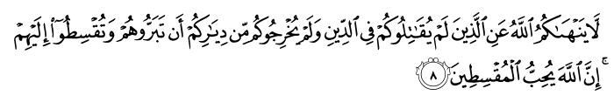

“Allah forbids you not, with regards to those who fight you not for (your) faithnor drive you out of your homes, from dealing kindly and justly with them.Indeed, Allah loves those who act justly.” (Quran 60:8)

When the caliph Omar conquered Jerusalem in 634, all religious communities were granted freedom of worship. Non Muslim minorities were allowed to create their own courts under Islamic law. Islam does not allow racism; instead, Islam emphasises on human dignity and all races and castes are equal in Allah's eyes.

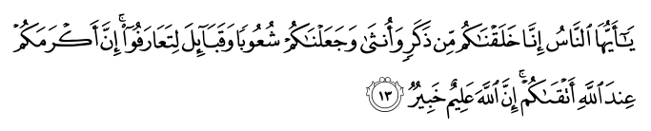

Abu Umamah reported: The Messenger of Allah, peace, and blessings be upon him, said:

“Verily, the best of the people to Allah are those who begin the greeting of peace.” (Sunan Abu Dawud 5197



* **Muslims worship different God:**

God is referred to as Allah in Arabic. For Muslims, Allah is the most inclusive of God's names and the greatest. It is an Arabic word, signifying the one and only God and indicating that He has no partners. It's the same word that the Jesus used in Aramaic when he prayed to God andJews use for God in Hebrew .

God has the same name In Judaism, Christianity, and Islam,; Allah is the same God worshipped by Christians ,Muslims, and Jews. Muslims believe that Allah's power must be recognized through worship and to follow His commandments, which were communicated by His messengers and prophets who appeared at different times for different people throughout history.

The God in Islam is One and Only. He is Exalted, does not gets tired, has no son (i.e. Jesus), no acquaintances, and no human-like ascriptions as found in Gods of Muslims are a locality of the fashionable world. Even the foremost hard-line Islamists try to work out a way to live as successful Muslims within the present, instead of seeking to travel back in time other religions.

In Quran Allah says,

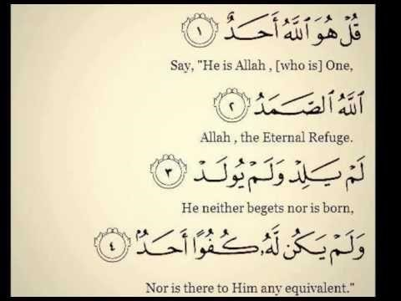

* **Muhammad (PBUH) was the founder of Islam:**

Muhammad was born in 570 in Mecca. Muhammad got his first revelation through the Angel Gabriel

from God at the age of40, while in a meditative retreat. The Quran is the name given to this revelation, which lasted for 23 years. He and his small community of followers were persecuted to the point that God gave them the order to emigrate in 622. The Hijrah, or migration, signals the start of the Muslim calendar year.

people think that the prophet pbuh was the person who has founded islam and Muslims worship him but it is not trueAlthough Muhammad (PBUH) was the last prophet who was chosen to deliver the message of Allah, Muslims do not consider him to be the "founder" of Islam. Muslims believe that all prophets, including Adam, Noah, Moses, and Jesus, were sent by God to provide divine guidance to their people, they were innocent and sinless.Theydon’t tell even a single word by themselves.

Every prophet was dispatched to his own people, but Muhammad (PBUH) was dispatched to the entire human race.

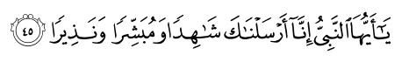

**“ O Prophet, verily We have sent you as a witness and a bearer of glad tidings and a warner and as one who invites unto Allah by His leave and as an illuminating lamp.”(Surah Al-Ahzab, Verse 45)**

* **All Muslim men marry four wives:**

Islam has been revealed for all cultures and times, and as a result, it can meet a wide range of social needs. Circumstances may authorize the husband to marry another wife, but only if the person is meticulously fair, according to the Quran. No woman can be coerced into this type of marriage if she does not want to be, and she also has the right to reject it.

Polygamy is neither required nor encouraged; but, it is permitted. Images of "sheikhs with harems" contradict Islamic teachings. A man is only permitted to have up to four wives if he can meet the strict requirements of treating each one separately and having separate accommodation. Islam governed, restricted, and humanized this activity, as well as establishing equal rights.

A legally married second wife who is treated well is better than a mistress or concubine who has no legal rights.

* **Media representation of Islam:**

Islam and Muslims are represented by media based on social-cultural contexts. Articles are made by media in a way that the reader will takes measures in favour of majority. Muslims are depicted as a society whose people are violating and hostile. In articles they say Muslimis terrorists, against freedom of speech. Different groups are participating in creating stereotypes about Islam. all Western journalist, authors and politicians encourage the islamophobia and Muslims stigmatization. The language used by them creates contradiction between us and them. They use negative opinions about Muslims because it’s the threat to security of west which is related to terrorist and Muslims.

**Conclusion and Recommendations:**

Quran is the book containing complete guidance for all mankind and it has solution to every problem .All these misconceptions and stereotypes are due to lack of knowledge about Islam. History proves that whenever a non-Muslim has studied Islam he converted to Islam because it is the ultimate religion .If you have proper knowledge, No one can misguide you To all humankind – Before you speak ask yourself if what you are going to say is true, is kind, is necessary, is helpful. If the answer is no, maybe what you are about to say left unsaid. A silent person is better than person uttering wrong and meaningless words.

. We do not presume we know anything to stop intellectual unawareness. Energy is wasted in creating islamophobia. It led to breaking of bonds between Muslim and non muslim identities. Uninterrupted by fear of loss, islamophobia is an fretfulness of a culture that strengths the energy of people creating it. In spite of the dispersed privileges which are associated with the presentation of one as a western matter, still a vast majority of people do not get the desired benefit from articulating and implementation islamophobia.

**References:**

* [**http://www.pbs.org/wgbh/globalconnections/mideast/questions/types/index.html**](http://www.pbs.org/wgbh/globalconnections/mideast/questions/types/index.html)
* [**https://www.adl.org/education/resources/tools-and-strategies/myths-and-facts-about-muslimpeople-and-islam**](https://www.adl.org/education/resources/tools-and-strategies/myths-and-facts-about-muslim-people-and-islam)
* [**https://www.beyondintractability.org/audiodisplay/abunimer-m-5-stereotypes1**](https://www.beyondintractability.org/audiodisplay/abunimer-m-5-stereotypes1)
* [**https://www.coe.int/en/web/interculturalcities/-/increasing-awareness-about-islam-andreducing-anti-muslim-stereotypes**](https://www.coe.int/en/web/interculturalcities/-/increasing-awareness-about-islam-and-reducing-anti-muslim-stereotypes)
* **https://link.springer.com/chapter/10.1007/978-3-319-58350-1_7**